Foods To Support The Liver

1. Garlic
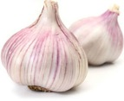
Just a small amount of this pungent white bulb has the ability to activate liver enzymes that help your body flush out toxins. Garlic also holds high amounts of allicin and selenium, two antioxidants that aid in liver cleansing.

2. Grapefruit (*not with medications)
High in both vitamin C and antioxidants, grapefruit increases the natural cleansing processes of the liver. A small glass of freshly-squeezed grapefruit juice will help boost production of the liver detoxification enzymes that help flush out carcinogens and other toxins.

3. Beets and Carrots
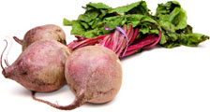
Both are extremely high in plant-flavonoids and beta-carotene; eating beets and carrots can help stimulate and improve overall liver function.

4. Green Tea
This liver-loving beverage is full of plant antioxidants known as catechins, a compound known to assist liver function. Green tea is not only delicious, it’s also a great way to improve your overall diet. It can also help boost metabolism.
5. Leafy Green Vegetables
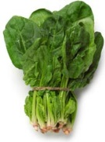
One of our most powerful allies in cleansing the liver, leafy greens can be eaten raw, cooked, or juiced. Extremely high in plant chlorophylls, greens suck up environmental toxins from the blood stream. With their distinct ability to neutralize heavy metals, chemicals and pesticides, these cleansing foods offer a powerful protective mechanism for the liver.
Try incorporating leafy greens such as bitter gourd, arugula, dandelion greens, spinach, mustard greens, and chicory into your diet. This will help increase the creation and flow of bile, the substance that removes waste from the organs and blood.

6. Avocados
This nutrient-dense super-food helps the body produce glutathione, a compound that is necessary for the liver to cleanse harmful toxins.

7. Apples
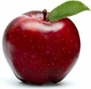
High in pectin, apples hold the chemical constituents necessary for the body to cleanse and release toxins from the digestive tract. This, in turn, makes it easier for the liver to handle the toxic load during the cleansing process.

8. Olive Oil
Cold-pressed organic oils such as olive oil are great for the liver, when used in moderation. They help the body by providing a lipid base that can suck up harmful toxins in the body. In this way, it takes some of the burden off the liver in terms of the toxic overload many of us suffer from.

9. Whole Grains
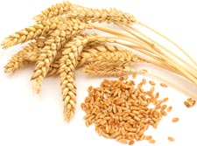Grains, such as brown rice and quinoa, are rich in B-complex vitamins which are needed for liver detoxification, function and liver decongestion. If possible, do not eat foods with white flour, instead try eating whole wheat alternatives or use coconut flour or ground almonds in cakes and breads.

10. Cruciferous Vegetables
Eating broccoli and cauliflower will increase the amount of glucosinolate in your system, adding to enzyme production in the liver. These natural enzymes help flush out carcinogens, and other toxins, out of our body which may significantly lower risks associated with cancer.

11. Lemons & Limes
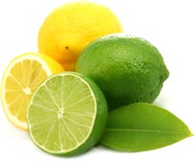These citrus fruits contain very high amounts of vitamin C, which aids the body in synthesizing toxic materials into substances that can be absorbed by water. Drinking freshly-squeezed lemon or lime juice in the morning helps stimulate the liver.

12. Walnuts
Holding high amounts of the amino acid arginine, walnuts aid the liver in detoxifying ammonia. Walnuts are also high in glutathione and omega-3 fatty acids, which support normal liver cleansing actions. Make sure you chew the nuts well (until they are liquefied) before swallowing.

13. Cabbage
Much like broccoli and cauliflower, eating cabbage helps stimulate the activation of two crucial liver detoxifying enzymes that help flush out toxins. Try eating more kimchi, coleslaw, cabbage soup and sauerkraut.

14. Turmeric
The liver’s favourite spice. Try adding some of this detoxifying goodness into your next stew or veggie dish for an instant liver pick-me-up. Turmeric helps boost liver detox, by assisting enzymes that actively flush out dietary carcinogens.
Other liver cleanse foods not listed above include artichoke, asparagus, kale, and brussel sprouts. Eating the foods listed above is a great way to help keep your liver functioning properly

-Dr. Edward F. Group III, DC, ND, DACBN, DABFM http://www.globalhealingcenter.com/natural-health/liver-cleanse-foods/

