Earl Grey Pan Glazed Salmon with Lemon Courgetti

This aromatic dish infuses delicate flavour by poaching the salmon in Earl Grey tea. Lemon courgetti makes a fresh and zingy accompaniment
NFSFGF
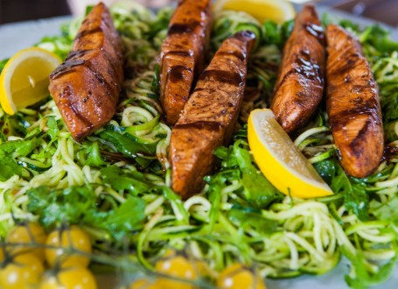
METHOD
- Place the contents of the tea bags in a teapot, cover with 300ml of freshly boiled water, stir, cover and leave to steep for seven minutes.
- Use a fine mesh strainer to strain the tea into a medium/large frying pan/skillet (large enough to fit the salmon fillets in one layer) and stir in the butter and maple syrup.
- Bring the pan to a medium simmer for 15 minutes, stirring occasionally, until the liquid has reduced by roughly half. Set aside to cool slightly.
- Meanwhile wash the courgettes and top and tail. Use a spiralizer or julienne peeler to make the courgetti – or use a regular vegetable peeler to slice the courgettes lengthways into very wide pappardelle-style ribbons. You might want to cut the long strands in half to make them easier to eat.
- To make the dressing whisk the olive oil and lemon juice together in a large bowl until emulsified (or shake in a jam jar). Stir in the chopped rocket and grated parmesan and season with black pepper. Taste and add more lemon if needed.
- Add the courgetti to the bowl, toss through the dressing and set to one side.
- Season the salmon fillets with sea salt and then place into the pan of tea glaze. Gently cook the fillets in the tea glaze on a medium heat for five minutes. Turn and cook for another four minutes on the other side until just pink inside (or when no resistance when pierced with a skewer).
- Serve the courgetti onto four plates and top each with a piece of salmon. Finish with a drizzle of leftover tea glaze from the pan.

Ingredients
Serves 4

Salmon & glaze
- 12 tea bags of Earl Grey tea/18g of Earl Grey tea leaves
- 300ml boiling water
- 4 tbs maple syrup
- 4 tbs butter
- sea salt
- 4 salmon fillets 500g

Courgetti & dressing
- 4 large courgettes
- 6 tablespoons extra virgin olive oil
- 2-3 tbs lemon juice
- 2 large handfuls rocket, finely chopped
- 2tbs Parmesan cheese, finely grated (maybe more)
- sea salt
- freshly ground black pepper

